**ABIN ROY 21MCA001**

**COMPUTER HARDWARE**

**What is a Processor?**

**Definition:** The processor is a chip or a logical circuit that responds and processes the basic instructions to drive a particular computer. The main functions of the processor are fetching, decoding, executing, and write back the operations of an instruction. The processor is also called the brain of any system which incorporates computers, laptops, smartphones, embedded systems, etc. The ALU (Arithmetic Logic Unit) and CU (Control Unit) are the two parts of the processors. The Arithmetic Logic Unit performs all mathematical operations such as additions, multiplications, subtractions, divisions, ,and the control unit works like traffic police, it manages the command or the operation of the instructions. The processor communicates with the other components also they are input/output devices and memory/storage devices

**Types of Processors**

There are different types of processors in the embedded system which include the following.

**General Purpose Processor**

There are five types of general-purpose processors they are, Microcontroller, Microprocessor, Embedded Processor, DSP and Media Processor.

**Microprocessor**

The general-purpose processors are represented by the microprocessor in embedded systems. There are different varieties of microprocessors available in the market from different companies. The microprocessor is also a general-purpose processor that consists of a control unit, ALU, a bunch of registers also called scratchpad registers, control registers and status registers.

There may be an on-chip memory and some interfaces for communicating with the external world like interrupt lines, other lines for the memory and ports for communicating with the external world. The ports often called the programmable ports that means, we can program these ports either to be acting as an input or as an output. The general-purpose processors are shown in the below table.

#### Microcontroller

The microcontroller is basically a computer that comes in various packages and sizes. The reading input and responding to output is the basic function of the microcontroller. Generally, it is known as General Purpose Input Output (GPIO). Some of the microcontrollers are Microchip Atmega328-AU, Microchip P1C16F877A-I/P, Microchip P1C16F1503-I/P, Microchip P1C16F671-I/SN, Microchip P1C18F45K22-I/P, etc.

#### Embedded Processor

An embedded processor is one type of processor which is designed to control mechanical functions and electrical functions. It consists of several blocks they are the processor, timer, an interrupt controller, program memory and data memory, power supply, reset and clock oscillator circuits, system application-specific circuits, ports and interfacing circuits.

### Digital Signal Processor

The digital signal processor is one type of processor used for measuring, filtering and/or compress digital or analog signals. The signal processing means analysis and manipulation of signal. This processing can be done via computer or [Application Specific Integrated Circuits (ASIC)](https://www.elprocus.com/application-specific-integrated-circuits/), Field Programmable Gate Array (FPGA) or Digital Signal Processor (DSP) to obtain the clear signal. The DSP processors are used in an oscilloscope, barcode scanners, mobile phones, printers, etc. These processors are fast and use for real-time applications. The typical DSP system is shown in the below figure.

### Media Processor

The image/video processor is the media processor that is designed or created to deal with the data in real-time. The voice user interface and professional audio are the applications of the audio processor. Some of the media processors are TN2302AP IP, IN2602 AP IP, DM3730, DM3725, DM37385, DM388, TMS320DM6467, TMS320DM6431,

MULTYPROCESSOR

The multiprocessor is a computer with more than one CPU, each shares main memory, a computer bus, and peripherals to simultaneously process the programs and these systems are also known as tightly coupled systems. The advantages of multiprocessors are increased throughput, increased reliability and economy of scale. These processors are used when very high speed is required to process a large volume of data. The symmetric multiprocessor is shown in the below figure.

* symmetric-multiprocessors 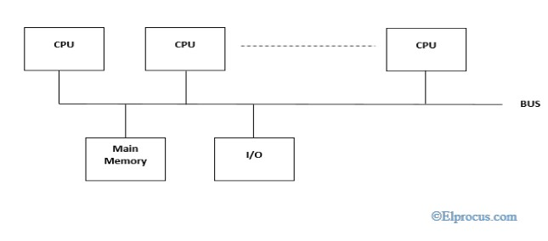

### Characteristics of Multiprocessors

The Characteristics of Multiprocessor are

* The multiprocessors consist of more than two processors or two processors which are similar
* Memory and input/output facilities shared by the processors
* The access time of the memory is the same for each processor because the processors are connected by bus
* Access to the input/output devices are shared by the processors
* The same function performed by all the processors

## 

## Motherboard

The motherboard is mounted inside the case and is securely attached via small screws through pre-drilled holes. Motherboard contains ports to connect all of the internal components. It provides a single socket for CPU, whereas for memory, normally one or more slots are available. Motherboards provide ports to attach the floppy drive, hard drive, and optical drives via ribbon cables. Motherboard carries fans and a special port designed for power supply.

There is a peripheral card slot in front of the motherboard using which video cards, sound cards, and other expansion cards can be connected to the motherboard.

On the left side, motherboards carry a number of ports to connect the monitor, printer, mouse, keyboard, speaker, and network cables. Motherboards also provide USB ports, which allow compatible devices to be connected in plug-in/plug-out fashion. For example, pen drive, digital cameras, etc.

## Features of Motherboard

A motherboard comes with following features −

* Motherboard varies greatly in supporting various types of components.
* Motherboard supports a single type of CPU and few types of memories.
* Video cards, hard disks, sound cards have to be compatible with the motherboard to function properly.
* Motherboards, cases, and power supplies must be compatible to work properly together.

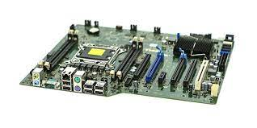

# 

# 

# **Memory module**

In [computing](https://en.wikipedia.org/wiki/Computing), a **memory module** or **RAM (random-access memory) stick** is a [printed circuit board](https://en.wikipedia.org/wiki/Printed_circuit_board) on which [memory](https://en.wikipedia.org/wiki/Computer_memory) [integrated circuits](https://en.wikipedia.org/wiki/Integrated_circuit) are mounted.[[1]](https://en.wikipedia.org/wiki/Memory_module#cite_note-1) Memory modules permit easy installation and replacement in electronic systems, especially computers such as [personal computers](https://en.wikipedia.org/wiki/Personal_computer), [workstations](https://en.wikipedia.org/wiki/Workstation), and [servers](https://en.wikipedia.org/wiki/Server_(computing)). The first memory modules were proprietary designs that were specific to a model of computer from a specific manufacturer. Later, memory modules were standardized by organizations such as [JEDEC](https://en.wikipedia.org/wiki/JEDEC) and could be used in any system designed to use them.

Types of memory module include:

* [TransFlash Memory Module](https://en.wikipedia.org/wiki/TransFlash_Memory_Module)
* [SIMM](https://en.wikipedia.org/wiki/SIMM), a single in-line memory module
* [DIMM](https://en.wikipedia.org/wiki/DIMM), dual in-line memory module
  + [Rambus](https://en.wikipedia.org/wiki/Rambus) memory modules are a subset of DIMMs, but are normally referred to as RIMMs
  + [SO-DIMM](https://en.wikipedia.org/wiki/SO-DIMM), small outline DIMM, a smaller version of the DIMM, used in laptops

Distinguishing characteristics of computer memory modules include voltage, capacity, speed (i.e., [bit rate](https://en.wikipedia.org/wiki/Bit_rate)), and [form factor](https://en.wikipedia.org/wiki/Computer_form_factor). For economic reasons, the large (main) memories found in personal computers, workstations, and non-handheld game-consoles (such as PlayStation and Xbox) normally consist of dynamic RAM (DRAM). Other parts of the computer, such as [cache memories](https://en.wikipedia.org/wiki/Cache_memory) normally use [static RAM](https://en.wikipedia.org/wiki/Static_RAM) ([SRAM](https://en.wikipedia.org/wiki/Static_random_access_memory)). Small amounts of SRAM are sometimes used in the same package as DRAM.[[2]](https://en.wikipedia.org/wiki/Memory_module#cite_note-2) However, since SRAM has high leakage power and low density, [die-stacked](https://en.wikipedia.org/wiki/Three-dimensional_integrated_circuit) DRAM has recently been used for designing multi-megabyte sized processor caches.[[3]](https://en.wikipedia.org/wiki/Memory_module#cite_note-3)

Physically, most DRAM is [packaged](https://en.wikipedia.org/wiki/Integrated_circuit_packaging) in black epoxy resin.

# **Daughtercard**

A daughtercard or [**daughterboard**](https://www.easytechjunkie.com/what-is-a-daughterboard.htm) is a type of [**circuit board**](https://www.easytechjunkie.com/what-is-a-circuit-board.htm) that gets added to an existing one. Its name is appropriate for its use, since it is connected to a “[**motherboard**](https://www.easytechjunkie.com/what-is-a-motherboard.htm)” or “main board.” The motherboard is the primary circuit board for a device. It is usually in the device as it is shipped from the factory. A daughtercard may be added later.

Some daughtercard designs are made so that engineers can add functionality to a device without requiring a lot more room inside its housing. These kinds of items are often called riser boards or risers. Some might also call them “mezzanine boards.”

Daughtercards are different from some other types of additional circuit boards that tech enthusiasts call “expansion cards.” In expansion cards, the circuit board is often plugged in through a gap in the housing of a computer or device. These expansion boards help to give a device more functionality, often for additional sound play or for better visuals on a high-tech monitor or screen. In contrast to the way expansion boards are used, a daughtercard can be a more fundamental enhancement for a device. Adding a daughtercard often requires getting into the guts of a device. That’s why some users might hire a professional to install it. Companies that make an electronic device might offer a daughtercard as part of an essential upgrade that allows the product to be used in more various ways.

With the rise of connective USB ports and other technology, it has become less necessary to upgrade devices with daughtercards or daughterboards. A lot of advanced use can be built into a wireless connection and “outsourced” to a remote server, rather than adding it physically into a desktop or laptop computer. However, some types of equipment might still get these kinds of additions as provided by the manufacturer. Computer and electronics makers choose the best ways of offering upgrades that they feel will match the needs and desires of their customer base. Since not a lot of laptop or computer users want to wrestle a daughtercard into an existing circuit board design, companies that sell to a consumer market will probably choose alternatives, or offer professional installation as a free service if they are offering a daughtercard as a way to upgrade a device.

# **Expansion slot**

Alternatively known as a bus slot or expansion port, an expansion slot is a connection or port inside a [computer](https://www.computerhope.com/jargon/c/computer.htm) on the [motherboard](https://www.computerhope.com/jargon/m/mothboar.htm) or [riser card](https://www.computerhope.com/jargon/r/risecard.htm). It provides an installation point for a hardware expansion card to be connected. For example, if you wanted to install a new video card in the computer, you'd purchase a video expansion card and install that card into the compatible expansion slot.

## Computer expansion slots

Below is a listing of expansion slots commonly found in a computer and the devices associated with those slots. Clicking any of the links below provide you with additional details.

* [**AGP**](https://www.computerhope.com/jargon/a/agp.htm) - [Video card](https://www.computerhope.com/jargon/v/video-card.htm).
* [**AMR**](https://www.computerhope.com/jargon/a/amr.htm) - [Modem](https://www.computerhope.com/jargon/m/modem.htm), [sound card](https://www.computerhope.com/jargon/s/souncard.htm).
* [**CNR**](https://www.computerhope.com/jargon/c/cnr.htm) - Modem, [network card](https://www.computerhope.com/jargon/n/nic.htm), sound card.
* [**EISA**](https://www.computerhope.com/jargon/e/eisa.htm) - [SCSI](https://www.computerhope.com/jargon/s/scsi.htm), network card, video card.
* [**ISA**](https://www.computerhope.com/jargon/i/isa.htm) - Network card, sound card, video card.
* [**PCI**](https://www.computerhope.com/jargon/p/pci.htm) - Network card, SCSI, sound card, video card.
* [**PCI Express**](https://www.computerhope.com/jargon/p/pciexpre.htm) - Video card, modem, sound card, network card.
* [**VESA**](https://www.computerhope.com/jargon/v/vesa.htm) - Video card.

## SMPS: Switched-Mode Power Supply/ Switching Mode Power Supply

SMPS stands for Switched-Mode Power Supply. It is an electronic power supply that uses a switching regulator to convert electrical power efficiently. It is also known as Switching Mode Power Supply. It is power supply unit (PSU) generally used in computers to convert the voltage into the computer acceptable range.

This device has the power handling electronic components that converts electrical power efficiently. Switched Mode Power Supply uses a great power conversion technique to reduce overall power loss.

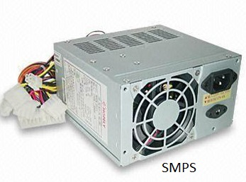

## How does SMPS work

The SMPS device uses switching regulators that switches the load current on and off to regulate and stabilize the output voltage. The average of the voltage between the off and on produces the appropriate power for a device. Unlike the linear power supply, the pass transistor of SMPS switches between low dissipation, full-on and full-off mode, and spends very less time in the high-dissipation transitions, which minimizes wasted energy.

## 

## 

## Internal Storage Devices

Some storage devices are classed as 'internal' which means they are inside the computer case.

Most computers have some form of internal storage. The most common type of internal storage is the hard disk.

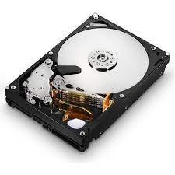 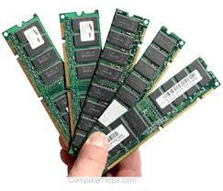

At the most basic level, internal storage is needed to hold the operating system so the computer is able to access the input and output devices.

It will also be used to store the applications software that you use and more than likely, the original copies of your data files.

Internal storage allows the data and applications to be loaded very rapidly into memory, ready for use. The data can be accessed much faster than data which is stored on an external storage device. This is because internal storage devices are connected directly to the motherboard and its data bus whereas external devices are connected through a hardware interface such as USB, which means they are considerably slower to access.

Internal storage also means that if the computer is moved around, it will still retain its most commonly used data.

The main disadvantage of internal storage is that when the hard disk fails (and it will), all the data and applications may be lost.

This can be avoided to some extent by using more than one hard disk within the machine. Each hard disk has a copy of all the data, so if one fails the other cancarry on. This is called a RAID array. An alternative is to use external drives for backup

# Computer – Ports

A port is a physical docking point using which an external device can be connected to the computer. It can also be programmatic docking point through which information flows from a program to the computer or over the Internet.

Characteristics of Ports

A port has the following characteristics −

* External devices are connected to a computer using cables and ports.
* Ports are slots on the motherboard into which a cable of external device is plugged in.
* Examples of external devices attached via ports are the mouse, keyboard, monitor, microphone, speakers, etc.

Let us now discuss a few important types of ports −

Serial Port

* Used for external modems and older computer mouse
* Two versions: 9 pin, 25 pin model
* Data travels at 115 kilobits per second

Parallel Port

* Used for scanners and printers
* Also called printer port
* 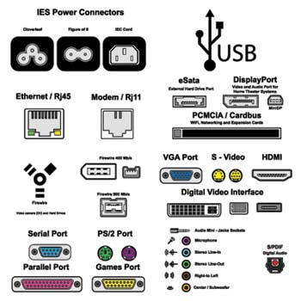25 pin model
* IEEE 1284-compliant Centronics port

PS/2 Port

* Used for old computer keyboard and mouse
* Also called mouse port
* Most of the old computers provide two PS/2 port, each for the mouse and keyboard
* IEEE 1284-compliant Centronics port

Universal Serial Bus (or USB) Port

* It can connect all kinds of external USB devices such as external hard disk, printer, scanner, mouse, keyboard, etc.
* It was introduced in 1997.
* Most of the computers provide two USB ports as minimum.
* Data travels at 12 megabits per seconds.
* USB compliant devices can get power from a USB port.

VGA Port

* Connects monitor to a computer's video card.
* It has 15 holes.
* Similar to the serial port connector. However, serial port connector has pins, VGA port has holes.

Power Connector

* Three-pronged plug.
* Connects to the computer's power cable that plugs into a power bar or wall socket.

Firewire Port

* Transfers large amount of data at very fast speed.
* Connects camcorders and video equipment to the computer.
* Data travels at 400 to 800 megabits per seconds.
* Invented by Apple.
* It has three variants: 4-Pin FireWire 400 connector, 6-Pin FireWire 400 connector, and 9-Pin FireWire 800 connector.

Modem Port

* Connects a PC's modem to the telephone network.

Ethernet Port

* Connects to a network and high speed Internet.
* Connects the network cable to a computer.
* This port resides on an Ethernet Card.
* Data travels at 10 megabits to 1000 megabits per seconds depending upon the network bandwidth.

Game Port

* Connect a joystick to a PC
* Now replaced by USB

Digital Video Interface, DVI port

* Connects Flat panel LCD monitor to the computer's high-end video graphic cards.
* Very popular among video card manufacturers.

Sockets

* Sockets connect the microphone and speakers to the sound card of the computer.